After watching and talking about the video, your child should be able to answer the following questions:

1. Describe the tropical rain forest.

2. Why is it dark on the floor (ground) of a tropical rainforest?

3. How have plants adapted to live in the tropical rainforest?

4. How is the tropical rainforest similar to a temperate deciduous forest? How is it different?

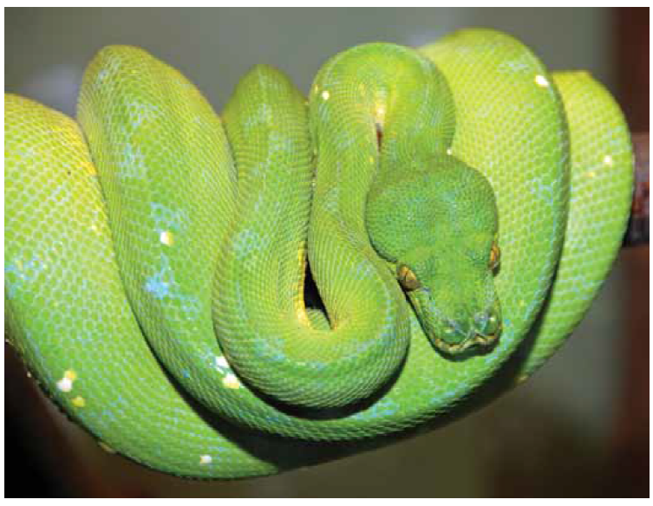 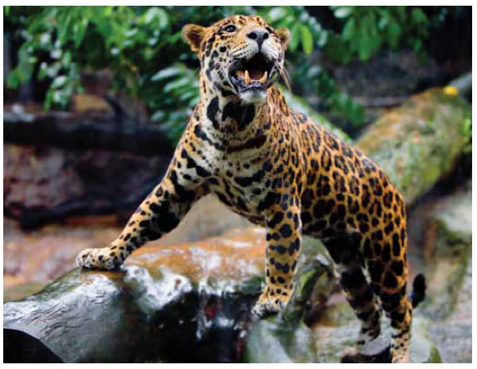 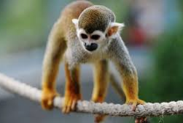

5. Think about the animals we read about. What adaptations do these animals have in order to live in the tropical rainforest?